
Imparting skills to drive change!

ASSIGNMENT 2.
Date: November 13th, 2019.

STUDENT NAME: Obwon Enock

COURSE: POST GRADUATE DIPLOMA IN WATER RESOURCES MANAGEMENT

MODULE TWO.
Topics
- Water Distribution Systems
- Engineering for Rural Water Supply

Skype: enock.obwon
Cell Phone: +256 787 970 056
Email.: enock@4-africa.com/enoch2054@gmail.com

- Explain how girls are victims of torture when the source of collecting water is far and inconveniencing, from the dimension of cultural beliefs & practices
In sub – Saharan Africa water sources are often far from the village, and women must walk for hours to fetch water daily. Some families even keep their daughters at home so that they can help collect water (Kramer, 2012). Instead of going to school, these girls walk, on average, at least 10 miles every day to get water, particularly when they must walk alone before or after daylight hours, women are vulnerable to rape and other violent attacks. The journey also requires them to carry buckets of water weighing over 40 pounds on their heads Carrying such a heavy load over long distances has detrimental health effects, including back and chest pains, developmental deformities, arthritic disease, and miscarriages.
Further drinking water in Sub-Saharan Africa is often just as hazardous as retrieving it. Women are not only at risk of sickness themselves, but are also responsible for taking care of family members who fall ill after drinking contaminated water. Furthermore, they may then have to take on the labor of the sick family member, on top of their own labor, while they nurse their loved ones back to health.
- Why do we need an alternative source of water in rural and slum areas and what options are available
Traditionally people in rural & slum areas have obtained water from unprotected ponds or tanks, wells, cisterns and sometimes streams and rivers. This water sources are frequented daily for collecting water for domestic use as well as livestock use. However, studies have shown that most of the water sources are normally contaminated by fecal matter. Consumption of contaminated water gives rise to a host of negative health outcomes. Infectious water-related diseases, particularly the diarrheal diseases, which are among the leading risks facing people living in slums & rural areas (UN 2007).

The diarrheal diseases are those illnesses that induce diarrhea as a major symptom, including, but not limited to, cholera, dysentery and typhoid (Butterton & Calderwood 2004). With an estimated 4 billion cases annually throughout the world, the diarrhoeal diseases are the most detrimental of all ailments related to water, sanitation and hygiene (Schuster-Wallace et al. 2008). Every year, the diarrhoeal diseases are responsible for more than 1.5 million deaths and the loss of 52 million DALYs (disability adjusted life years) globally. Tragically, these diseases disproportionately affect impoverished children under the age of ﬁve, particularly those living in slums (Marsh et al. 1995). Almost 1.4 million of the deaths caused by diarrhoeal diseases are among children (Pruss-Ustun et al. 2008).

Alternative decentralized water treatment systems have been promoted in recent years as a means of achieving rapid health gains among vulnerable populations. Though much work with decentralized systems, especially in urban environments, has been at the household level, there is also considerable potential for development at the community level (Imran, 2010). The capital costs associated with decentralized systems may also be substantially lower than those for centralized systems, owing to savings on distribution networks. Decentralized systems are, for these reasons, increasingly being advocated as a means to ﬁll the safe water gap before the extension of effective centralized water networks (Mintz et al. 2001; Sobsey 2002; Thompson et al. 2003; NRC 2006; Montgomery & Elimelech 2007) such as rainwater harvesting & Groundwater.
- Explain the process of harvesting rainwater in rural areas
Rainwater with reasonable qualities can be collected from rooftop areas that can be stored to provide individual households in rural areas with adequate water supplies. This is done by directing the rainfall on the roof areas to flow through simple collection gutter arrangements, water that would otherwise join surface run-off can be gainfully utilized. Roofs made of tiles, slates, corrugated iron/ tin or asbestos sheets are more suitable. Thatched and lead sheet roofs are not suitable because of health hazards.
The roof guttering should slope evenly towards a downpipe to avoid sagging and hence pooling of water that may become a breeding place for mosquitoes. It may be helpful to arrange to divert the first flush of water from a roof collection, as it will wash with it the accumulated dust and impurities such as bird droppings, dead leaves, etc. The roof and guttering should be cleaned regularly. A wire mesh placed over the top of the downpipe would prevent it from becoming clogged with washed-off materials

- Explain how community water catchment areas are protected in rural areas from extinction and from contamination
Water catchments for community water supply require proper management and maintenance so as to prevent any occurrence of contamination. Communities have therefore carried out this through or by fencing or hedging to protect against damage and contamination. Trees and shrubs can be planted around catchment to limit the entry of windblown materials and dust into the catchment area.
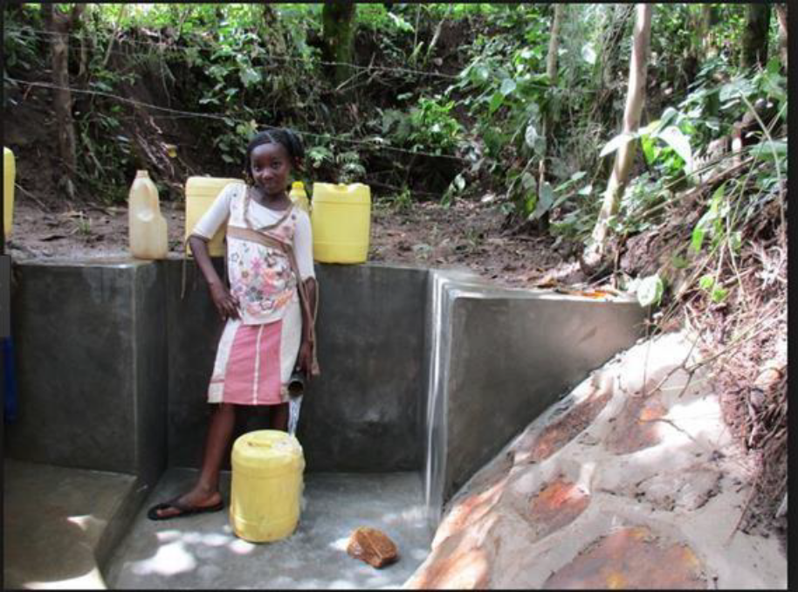
A girl standing next to a well-managed community water point
- Explain how the water distribution system can be a source of diseases to the water cycle and how it can be reversed
Water distribution systems are inherently susceptible to both intentional and accidental contamination. As shown in Figure below, there are numerous points at which a contaminant may enter the distribution system. These range from major components such as treatment plants, pumps and tanks, to individual hydrants and customer connections. Since it is highly infeasible (or virtually impossible) to fully protect all potential points of entry (Grayman 2005).
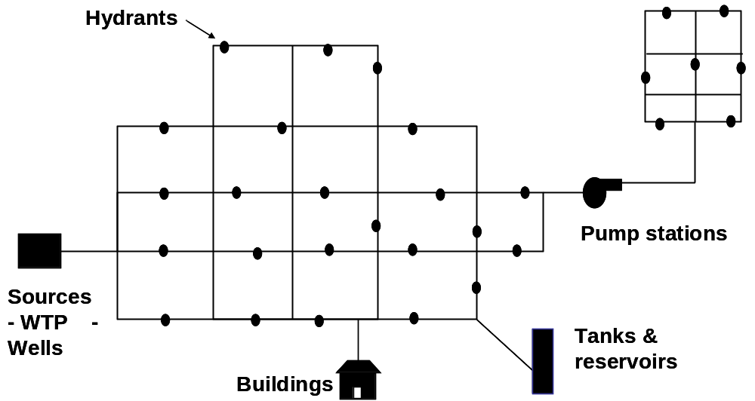

Figure 1: Example potential entry points for contaminants into a distribution system,
Courtesy Walter M. Grayman, PhD, PE.
Therefore, intrusion of contaminated water into drinking water distribution systems can result in exposure to consumers after the water has been treated. Intrusions can occur from cross connection with water containing wastes, changes in water pressure or intentional addition from terrorist-motivated events. Transient negative pressure events (which create suction into the pipes) can occur in pipelines, and if leaks are present, they provide a potential portal for water into the distribution systems hence leading to contamination of water leading to spread of diseases(Charles et al, 2015)
Deteriorating water treatment facilities and distribution systems pose a significant public health threat, particularly in republics of the former Soviet Union. Interventions to decrease the disease burden associated with these water systems range from upgrading distribution networks to installing reverse osmosis technology (Semenza et al, 1998)
Using models not only to estimate risk but also to aid in design of the municipal water distribution system, as such help in deciding where to place real-time sensors in the system. This is important because the inability to predict accurate water quality in water distribution systems could lead to either under- or over-design of water treatment infrastructures. Models available for such utilities and researchers include EPANET, which was released by the United States Environmental Protection Agency (Rossman, 2000)

- Explain how the distribution system of water in an urban center should take care of hydrants
Hydrants are primarily part of the firefighting aspect of a water system. Proper design, spacing and maintenance are needed to ensure an adequate flow to satisfy fire-fighting requirements. They should be placed in areas that are accessible, away from pedestrians and vehicles to ensure that when we have an emergency they can be accessed easily and efficiently. In addition to being used for firefighting, hydrants are also for routine flushing programs, emergency flushing, preventive flushing, testing and corrective action, and for street cleaning and construction projects (AWWA, 1986).

- Explain in great detail the uses of storage tanks
Storage tanks are used to provide storage capacity to meet fluctuations in demand (or shave off peaks), to provide reserve supply for fire-fighting use and emergency needs, to stabilize pressures in the distribution system, to increase operating convenience and provide flexibility in pumping, to provide water during source or pump failures, and to blend different water sources. The recommended location of a storage tank is just beyond the center of demand in the service area (AWWA, 1998). Elevated tanks are used most frequently, but other types of tanks include in-ground tanks and open or closed reservoirs. Common tank materials include concrete and steel.
An issue that has drawn a great deal of interest is the problem of low water turnover in these facilities resulting in long detention times. Much of the water volume in storage tanks is dedicated to fire protection, and unless utilities properly manage their tanks to control water quality, there can be problems attributable to both water aging and inadequate water mixing. Excessive water age can be conducive to depletion of the disinfectant residual, leading to biofilm growth, other biological changes in the water including nitrification, and the emergence of taste and odor problems. Improper mixing can lead to stratification and large stagnant (dead) zones within the bulk water volume that have depleted disinfectant residual. As discussed later in this report, neither historical designs nor operational procedures have adequately maintained high water quality in storage tanks (Clark et al., 1996)
Security is an important issue with both storage tanks and pumps because of their potential use as a point of entry for deliberate contamination of distribution systems

References.
American Water Works Association(AWWA). (1986). Introduction to Water Distribution Principles and Practices of Water Supply Operations. Denver, CO: AWWA.
AWWA. (1998). AWWA Manual M31: Distribution system requirements for fire protection. Denver, CO: AWWA.
Butterton, J. R. & Calderwood, S. B. (2004). Acute infectious diarrheal diseases and bacterial food poisoning. In Harrison’s Principles of Internal Medicine, 16th Edition. McGraw-Hill Professional, UK
Clark, R. M., Geldreich E.E., Fox K.R, Rice E.W., Johnson H.C., Goodrich J.A., Barnick J.A., and Abdesaken F. (1996). Tracking a Salmonella Serovar Typhimurium Outbreak in Gideon, Missouri: role of contaminant propagation modeling. Journal of Water Supply Research and Technology–Aqua 45(4):171–183.
International Museum of Women. Retrieved from http://www.vossfoundation.org/assets/Water-Woes-International-Museum-of-Women.pdf
Marsh, D., Husein, K., Lobo, M., Shah, M. A. & Luby, S. (1995). Verbal autopsy in Karachi slums: comparing single and multiple cause of child deaths. Health Policy Plann. 10(4), 395–403.
Mintz, E., Bartram, J., Lochery, P. & Wegelin, M. (2001). Not just a drop in the bucket: expanding the access to point-of-use water treatment systems. Am. J. Public Health 91(10), 1565–1570
Montgomery, M. & Elimelech, M. (2007). Water and sanitation in developing countries: including health in the equation. Environ. Sci. Technol. 41(1), 17–24
NRC (2006). Drinking Water Distribution Systems: Assessing and Reducing Risks. National Academies Press, Washington, DC
Pruss-Ustun, A., Bos, R., Gore, F. & Bartram, J. 2008 Safer Water, Better Health: Costs, Beneﬁts, and Sustainability of Interventions to Protect and Promote Health. World Health Organization, Geneva
Schuster-Wallace, C., Grover, V., Adeel, Z., Confalonieri, U. & Elliott, S. (2008). Safe Water as the Key to Global Health. United Nations University International Network on Water, Environment, and Health (UNU-INWEH), Hamilton
Semenza, J.C., Roberts., Henderson, A., Bogan, J. & Rubin, C.H. (1998). Water Distribution systems & Diarrheal disease transmission: A case study in Uzbekistan., 59(6). Pp. 941-946
Sobsey, M. (2002). Managing water in the home: accelerated health gains from improved water supply. In Protection of the Human Environment: Water, Sanitation and Health. World Health Organization, Geneva
Syed, I.A. (2010). Alternatives for Safe water provision in Urban & Peri – Urban slums., 8(4). Pp. 720-734
Thompson, T., Sobsey, M. & Bartram, J. (2003). Providing clean water, keeping water clean: an integrated approach. Int. J. Environ. Health Res. 13, S89–S94
UN 2007 The Millennium Development Goals Report. United Nations Department of Economic and Social Affairs, New York
Water for Life. Retrieved from http://www.vossfoundation.org/assets/WHOUNICEF-Water-for-Life-2005.pdf

